[w w w . a p p l e . c o m](https://www.apple.com/)

S T  C K

P I T C H

2 0 2 5

**APPLE**

STOCK PITCH PAGE 02

**Table Of Contents**

**Executive Summary Industry Analysis**

**03**

**07**

**About Company Financial Analysis**

**08**

**04**

**Company Analysis**

**05**

**11**

**Risks and Assumptions**

**Competitor Analysis**

**09**

**06**



**Recommendation**

# EXECUTIVE SUMMARY

This report evaluates Apple Inc.' s strategic positioning amid its shift toward AI- driven innovation and a growing services ecosystem, assessing its financial

performance, product adoption, and market challenges to determine the viability of a Buy recommendation.

1. Financial Performance

Apple’ s revenue grew from $ 365 . 8 billion in FY 2021 to $ 396 . 8 billion in

FY 2025 , with net income rising from $ 94 . 5 billion to $ 106 . 4 billion over the same period, reflecting steady growth and strong cost management.

1. Product Innovation and Market Response

While Apple introduced AI features in the i Phone 16 and the Vision Pro

headset, market reception has been lackluster, prompting a 50 % cut in Vision Pro production.

1. Services Segment Growth

Apple’ s services division, including digital content and subscriptions, is now a key revenue driver, providing recurring income and reducing reliance on

hardware cycles.

1. Operational Efficiency

With a peak Return on Equity ( ROE) of 175 . 46 % in FY 2022 and stable Return on Assets ( ROA), Apple demonstrates efficient capital utilisation.

1. Valuation Premium

Apple’ s forward Price- to- Earnings ( P/E) ratio of 25 . 83 reflects investor confidence, trading at a 41 % premium over industry peers, underscoring strong market expectations for its future growth.

These insights indicate Apple’ s financial resilience, the growing importance of its services segment, and market confidence in its long- term potential, despite

challenges in product adoption.

The results are important because they provide insight into Apple Inc.' s ability to adapt to changing market conditions, innovate effectively, and maintain strong

financial performance. The growth of its services segment reduces reliance on hardware cycles, offering greater revenue stability. Despite mixed product

reception, Apple' s efficient operations and strategic focus on AI and services

position it well for long- term growth, making it a key player in the evolving tech landscape.

# ABOUT COMPANY

Apple Inc. is a U. S.- based multinational technology company and one of the most valuable and recognisable brands in the world. It designs, manufactures, and sells a wide range of consumer electronics, including the i Phone, i Pad, Mac, Apple

Watch, and Air Pods. In addition to hardware, Apple develops its software

platforms— i OS, mac OS, and watch OS— and operates a rapidly growing services

business that includes the App Store, Apple Music, i Cloud, and Apple Pay. With a vertically integrated ecosystem and loyal customer base, Apple has built a

powerful platform that drives recurring revenue across hardware and services.

In recent years, Apple has shifted its focus from purely hardware innovation to broader strategic goals centered on artificial intelligence ( AI), services growth,

and regional market expansion. In 2024 , Apple launched the i Phone 16 with new AI capabilities and announced a $ 1 billion investment in AI data centres. It also partnered with Alibaba to strengthen its presence in China, an increasingly

competitive but critical market. These moves reflect Apple’ s push to remain competitive as AI becomes a defining force in consumer tech.

However, not all product launches have met expectations. The Vision Pro, a

$ 3 , 499 mixed- reality headset launched in early 2024 , received mixed reviews,

leading Apple to cut production by 50 %. Additionally, demand for the AI- powered i Phone 16 has been softer than anticipated, suggesting that the market is still

adjusting to AI integration in everyday devices.

Financially, Apple remains strong. From Figure 1 , Revenue grew from $ 365 . 8

billion in 2021 to $ 396 . 8 billion in 2025 , with a slight dip in 2023 . Net income rose from $ 94 . 5 billion to $ 106 . 4 billion over the same period. Gross profit

steadily increased, reaching $ 184 . 1 billion in 2025 . These trends reflect solid cost management and consistent profitability, even amid shifting market dynamics.

Apple’ s strong balance sheet, brand loyalty, and focus on services and AI give it

long- term resilience. However, slower product adoption and rising competition in key markets suggest potential volatility in the short term.

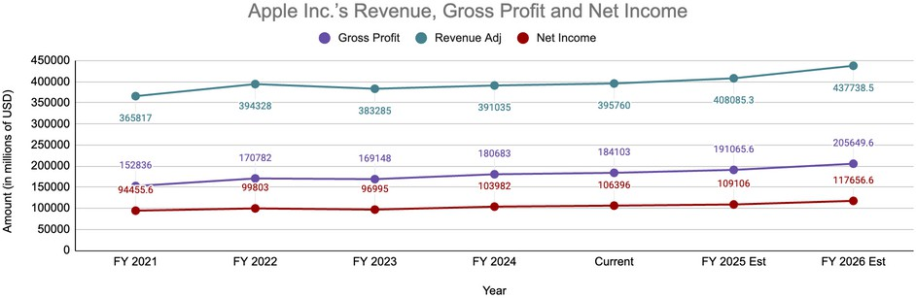

**Figure 1: Graph of Apple Inc.’s Revenue, Gross Profit, and Net Income (2021–2025)**

# COMPANY ANALYSIS

Apple’ s recent product strategy signals a pivot toward AI- led innovation, though

results have been mixed. The i Phone 16 introduced new AI features, including on- device intelligence and contextual automation, positioning Apple in the race to

embed generative AI into consumer tech. However, early consumer response has been lukewarm, with weaker- than- expected demand suggesting l imited perceived value for the new AI capabilities. Similarly, the Vision Pro— Apple’ s first major

entry into the mixed reality space— has struggled to gain traction. Priced at

$ 3 , 499 , the headset faced criticism over comfort and functionality, leading to a 50 % reduction in production targets from one million to 400 , 000 units for 2024 .

These issues highlight a disconnect between Apple’ s innovation pipeline and consumer readiness, raising questions about the timing and market fit of its emerging technologies.

Apple is facing significant challenges from both external and internal factors.

Operating expenses have been rising as the company increases its investment in Research and Development ( R& D), particularly in AI, and expands its services

infrastructure. Additionally, ongoing U. S.– China trade tensions have reintroduced tariff exposure on Chinese imports, directly impacting the costs of Apple’ s

hardware manufacturing. The potential for escalating trade friction poses a

longer- term risk to the company’ s profit margins. Moreover, the high production

costs and underperformance of the Vision Pro are adding further strain to Apple’ s hardware cost structure.

Regulatory challenges are another growing concern. Apple is under scrutiny from multiple global regulators over its App Store practices, especially in the EU. In

early 2025 , France’ s antitrust authority fined Apple € 150 million for allegedly

abusing its dominant market position through its App Tracking Transparency( ATT) feature, which disproportionately affected smaller developers. Moreover, China is considering a probe into Apple’ s App Store fees, which could further impact

services revenue from one of its most important markets. These legal pressures

could lead to both reputational and financial costs i f Apple is forced to revise its monetisation strategies.

Amid these challenges, Apple is undergoing a strategic shift toward AI and

services- led growth. The company recently announced a $ 500 billion investment in the U. S. over the next four years, focused on AI infrastructure, custom silicon

development, and workforce expansion. Partnerships l ike the one with Alibaba for AI development in China also reflect Apple’ s intent to stay competitive globally.

Services revenue remains a pillar of stability, providing high- margin, recurring

income that cushions hardware- related volatility. This shift toward a services- and software- driven business model could help Apple sustain long- term profitability,

even as hardware growth slows.

# COMPETITOR ANALYSIS

Apple operates in a highly competitive landscape, facing pressure from both

global tech giants and agile regional players. Competitors l ike Google, Samsung,

Honor, and Huawei are advancing in AI, while also benefiting from regulatory changes that could affect Apple’ s market position.

Apple’ s decision to remove end- to- end encryption in the UK could drive privacy- conscious customers to alternatives l ike Google’ s Pixel, which offers stronger

privacy protections. As concerns over encryption grow, competitors with better privacy features may attract more users. Additionally, regulatory pressures, such as potential changes to Section 230 , could force Apple to adjust its App Store

recommendation algorithms. This would increase operational costs and benefit competitors with more flexible content moderation models.

Apple’ s reliance on its premium pricing strategy is becoming a potential obstacle in emerging markets, where local brands l ike Xiaomi, Honor, and Huawei offer

high- quality, affordable alternatives. In regions such as China and India, where price sensitivity is high, Apple’ s premium- priced products may struggle to

maintain market share against these more affordable options. As local competitors continue to enhance their product offerings, particularly with AI and other

advanced features, Apple may face further pressure to adjust its pricing strategy or introduce more budget- friendly models to remain competitive in these regions.

While Apple’ s services, including the App Store and i Cloud, are growing faster than its hardware business, ongoing regulatory scrutiny over fees and content moderation could weaken its competitive position. I f competitors avoid similar regulatory challenges, Apple’ s advantage could shrink.

In international markets, Apple faces fierce competition from local brands l ike Honor and Huawei. These brands are gaining traction in China and India with

affordable, AI- powered products. Huawei’ s strong presence in China, bolstered by national loyalty and AI innovation, poses a serious threat to Apple’ s market share.

I f local consumers continue to prefer these brands, Apple could see a decline in sales.

Apple faces strong competition in AI innovation from companies l ike Nvidia.

Nvidia leads in AI chips, leaving Apple behind in this fast- evolving field. As

investors shift focus to AI- driven companies, concerns grow about Apple’ s ability to sustain growth unless it increases its AI investments.

Apple faces mounting challenges from regulatory pressures, local competitors, and rapid advances in AI. To maintain its market position, Apple will need to adapt

quickly to these evolving pressures and innovate in areas l ike AI and privacy.

# INDUSTRY ANALYSIS

The consumer technology industry is in the midst of a structural transformation, driven by rapid advancements in artificial intelligence, shifts in consumer

behaviour, regulatory developments, and evolving global supply chains. As a

market leader, Apple exemplifies many of these trends, offering a lens into how major players are navigating the changing landscape.

The integration of artificial intelligence is reshaping the competitive dynamics of the industry. Companies are embedding AI into mobile operating systems,

personal assistants, and device- level functionalities to enhance user experience

and drive differentiation. Apple’ s recent expansion of its AI suite, branded “ Apple Intelligence” through i OS 18 . 4 , reflects a wider industry push toward

personalisation and predictive capabilities. However, analysts remain sceptical about whether these innovations will be sufficient to reverse stagnating

smartphone demand. Simultaneously, foldable technology is gaining traction

across the industry, and Apple’ s anticipated entry into this sector with a foldable i Phone, reportedly priced between $ 2 , 000 and $ 2 , 500 , signals a broader industry focus on reimagining device form factors to reignite consumer interest.

Amid economic uncertainty and high inflation, consumers are holding onto their devices longer. Industry- wide, there has been a significant increase in the

proportion of users replacing smartphones every five years or more, rising from under 20 % in 2022 to over 31 % by the end of 2023 . This is consistent with

Apple’ s internal trends, where 71 % of current i Phone owners report that their previous device was over two years old, up from 63 % in 2020 . These patterns highlight a growing resistance to frequent upgrades, emphasising the need for manufacturers to deliver compelling long- term value.

The global regulatory environment is becoming increasingly assertive, particularly in the European Union. The industry is facing growing scrutiny over platform

dominance, app store fees, and market competition. Apple has been charged with violating EU competition rules, with regulators targeting its treatment of rival

music streaming services l ike Spotify. Although potential fines under the EU’ s

Digital Markets Act may be small, they could still result in substantive changes to platform policies. These developments are being closely watched across the

industry, as they set important precedents for how tech giants operate in global markets moving forward.

Moreover, supply chain diversification has become a strategic priority for many consumer technology firms. In response to geopolitical tensions and recent

disruptions, companies are actively working to reduce reliance on a single region, particularly China, by expanding manufacturing operations to countries l ike India and Vietnam. Apple’ s ongoing shift in production reflects this broader industry

movement toward building more resilient and geographically balanced supply chains.

# FINANCIAL ANALYSIS

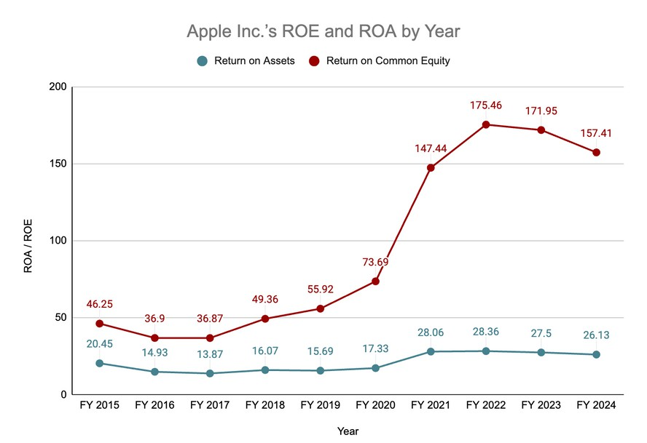

**Figure 2: Graph of Apple Inc.’s ROA and ROE (2015–2024)**

As seen in Figure 2 , Apple has exhibited strong financial performance, with

its Return on Equity ( ROE) rising from 46 . 25 % in 2015 to a peak of 175 . 46 % in 2022 . During the same period, its Return on Assets ( ROA) remained

relatively stable, fluctuating between 13 . 87 % and 28 . 36 %.

The increasing gap between ROE and ROA reflects Apple’ s effective use of financial leverage and share repurchase programs, suggesting a positive

outlook for its ability to drive shareholder value in the future.

From 2022 to 2024 , ROE has slightly declined but remains at historically

elevated levels, while ROA has stayed relatively stable. This trend indicates that while the effects of aggressive financial strategies may be moderating, Apple' s underlying operational efficiency remains strong.

Based on the data, we expect ROE and ROA to stabilise at high levels, which supports a positive future trajectory for Apple' s financial strength and could contribute to sustained or rising stock prices.

# FINANCIAL ANALYSIS

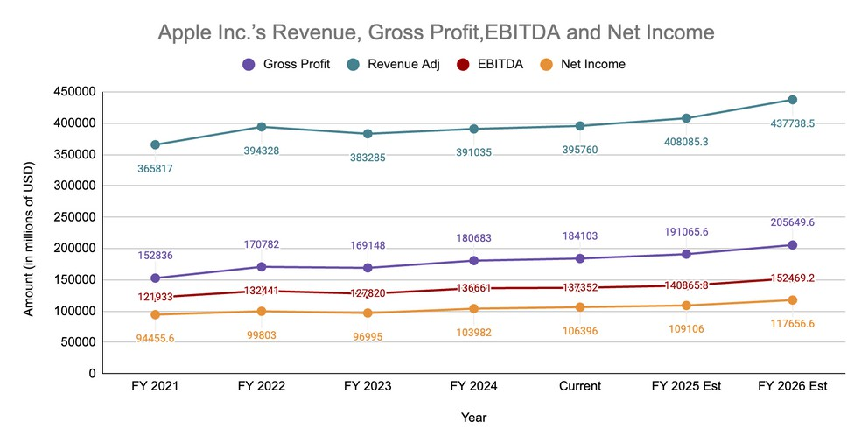

**Figure 3: Graph of Apple Inc.’s Revenue, Gross Profit, EBITDA and Net Income (2021–Estimated 2026)**

As seen from Figure 3 , Apple has demonstrated consistent financial strength and operational excellence. From FY 2021 to FY 2024 , revenue has grown from

$ 365 . 8 B to $ 395 . 8 B, showing a steady increase in income from its product sales and services. Gross profit followed a similar trend, increasing from $ 152 . 8 B to

$ 184 . 1 B, reflecting stable margins due to strong pricing power and high- margin services revenue. EBITDA has remained strong and gradually improved, rising

from $ 121 . 9 B in FY 2021 to $ 137 . 4 B in the current year, indicating sound

operational efficiency. Net income, while slightly volatile due to one- off factors and potential tax impacts, has consistently remained above $ 94 B, increasing to

$ 106 . 4 B in the current year.

Looking forward, all key metrics are projected to rise meaningfully in FY 2025 and FY 2026 , with revenue expected to hit $ 437 . 7 B and EBITDA reaching

$ 152 . 5 B by FY 2026 . This anticipated growth reflects optimism around Apple' s

product pipeline and expansion in services. The growth in net income to $ 117 . 7 B by FY 2026 suggests continued strong profitability and cash generation.

This reflects Apple' s resilience and its ability to generate value across different economic cycles. The company’ s continued focus on innovation, ecosystem

integration, and services diversification enhances its growth visibility. Apple’ s consistent financial performance reflects its strategic focus on innovation and

operational efficiency. The steady revenue and gross profit growth highlight its strong pricing power and the expanding services segment. With rising EBITDA

and net income projections, Apple is well- positioned to capitalize on its product pipeline and services growth, ensuring continued profitability and resilience in

the face of market challenges.

# FINANCIAL ANALYSIS

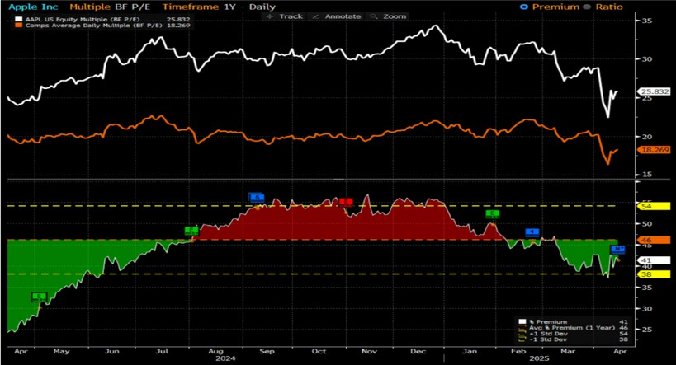

**Figure 4: Graph of P/E for Apple vs Comparables(2024-2025)**

As seen in Figure 4 , Apple’ s current forward Price- to- Earnings ( P/E) ratio stands at 25 . 83 , which is significantly higher than the peer average of 18 . 27 . This peer group includes companies l ike Samsung Electronics and HTC Corp. The P/E ratio tells us how much investors are willing to pay today for $ 1 of Apple’ s expected

future earnings. A higher P/E ratio means that investors are optimistic about Apple’ s future and are willing to pay more for its shares because they expect strong earnings growth.

Currently, Apple is trading at a 41 % premium compared to its peers ( 25 . 83 vs. 18 . 27 ) , which means investors are paying 41 % more per dollar of earnings for Apple than for similar tech companies. Historically, over the past year, this

premium averaged around 46 %, as shown by the orange dashed l ine. The fact that the current premium is slightly below the average suggests that Apple’ s stock is a l ittle less expensive relative to its own historical norm, even though it’ s still quite expensive compared to competitors.

This slight dip in valuation premium could be due to Apple’ s slower performance in FY 2024 , where growth in revenue and net income was more modest compared

to prior years. However, the company is still valued highly because investors trust its long- term growth potential— especially in services, wearables, and future

innovation.

I f the company meets or exceeds the growth expectations as shown in Fig 3 , the current P/E ratio could be justified or even increase, which would support a

higher stock price over the next 12 months. On the other hand, i f earnings

disappoint or growth slows, the high P/E could become a red flag, and the stock might face downward pressure as investors reevaluate whether Apple is worth

such a premium.

# RISKS AND ASSUMPTIONS

Apple’ s recent performance reveals certain short- term risks, but these are largely manageable and may already be reflected in the stock price. This

presents potential upside for long- term investors. Initial Vision Pro sales have been modest, raising questions about Apple’ s position in the AR/VR space.

However, as a first- generation product in a developing market, slower

adoption is expected. Apple’ s history of refining and scaling new technologies suggests strong potential for future success. Similarly, softer demand for the

i Phone 16 and signs of upgrade fatigue may temporarily affect hardware sales, but these are cyclical trends that do not compromise the company’ s overall

growth potential. While geopolitical exposure, particularly in China, poses a risk, Apple’ s global scale and operational agility provide the flexibility to

manage such challenges effectively.

For the stock price to increase, certain assumptions must hold true. First,

Apple must successfully introduce a new product or service that generates

consistent, recurring revenue. This could include an advanced version of the Vision Pro headset or a new AI- powered device that captures consumer

interest and creates a steady income stream. Apple’ s iterative approach to

product development and the integration of AI into its devices are expected to drive renewed consumer interest and support a new upgrade cycle. The

continued expansion of its high- margin services segment is crucial as it adds recurring revenue and helps smooth earnings volatility. Introduction of new high- margin subscription offerings or software that enhances its ecosystem,

will further grow its services segment. Finally, the company needs to maintain operational efficiency, optimise its supply chain and adapt to global regulatory pressures without significant financial setbacks. Together, these factors

support Apple’ s earnings growth and premium valuation, making the stock an attractive long- term investment.

These assumptions are critical because they ensure a steady growth trajectory which supports long- term profitability and investor confidence. I f any of these assumptions fail to materialize, such as weak product adoption or regulatory

challenges, Apple’ s ability to sustain its current valuation could be compromised, ultimately affecting its stock price.

# RECOMMENDATION

We recommend a Buy on Apple Inc. as we expect stock price to increase over the next 12 months, This is underpinned by its strong financial fundamentals, growing services segment, strategic investment in artificial intelligence, and

resilience amidst macroeconomic headwinds.

Apple continues to demonstrate operational excellence and financial resilience, with consistent cash flow generation, a robust balance sheet, and industry-

leading margins. Despite short- term dips in i Phone sales, Apple has maintained strong customer loyalty and ecosystem stickiness, supporting recurring revenue streams from its services segment.

The company' s recent push into AI integration and next- generation product

development signals a commitment to remaining at the forefront of innovation.

As generative AI becomes embedded into consumer technology, Apple’ s

emphasis on privacy- centric, on- device AI and seamless user experience will l ikely set it apart from competitors in both developed and emerging markets.

Moreover, Apple’ s global footprint and premium brand give it a strategic edge

in scaling new technologies. The expansion of its installed base in fast- growing markets l ike India and Southeast Asia further diversifies its revenue streams,

mitigating saturation risk in mature markets.

While challenges such as regulatory scrutiny and competition from Chinese Original Equipment Manufacturers ( OEMs) persist, we believe these risks are

well- priced into current valuations. Apple’ s strong capital allocation strategy,

including aggressive share buybacks and steady dividend payouts, adds further shareholder value.

Given its leadership in hardware- software integration, increasing monetisation of services, and long- term upside from AI- powered innovation, we see Apple as well- positioned for sustainable growth. Investors with a medium to long- term

horizon should consider taking or increasing their position in Apple Inc( AAPL).

Note: This report was prepared before the announcement of the Trump- era

tariff reinstatements and does not reflect the potential implications of those developments.

# References

Alvarez, J., & Doan, L. ( 2025 , February 25 ) . Apple joins tech firms pledging over $ 1 trillion in US spending. Bloomberg News.

Buckley, T. ( 2025 , February 27 ) . Warner Bros. movie co- heads are burning through cash, irking CEO. Bloomberg News.

Drozdiak, N. & Wickham, A. ( 2025 , February 27 ) . Gabbard calls for Investigation of UK’ s Apple Backdoor Request. Bloomberg News.

Fan, E. ( 2025 , February 16 ) . Apple reports i Cloud login and storage glitches. Bloomberg News.

Gopal, P., Carson, B. & Clanton, A. ( 2025 , February 27 ) . Silicon Valley Homes Are Flying Off the Market in Just Nine Days. Bloomberg News.

Gurman, M. ( 2025 , February 16 ) . Apple and Meta Are Set to Battle Over Humanoid Robots: Power On. Bloomberg News.

Gurman, M. ( 2025 , March 2 ) . Apple’ s AI efforts are already at make- or- break point: Power On. Bloomberg News.

Gurman, M. ( 2025 , March 2 ) . Apple’ s i Phone enters one of its most pivotal years: Power On. Bloomberg News.

Kleban, R., Tugaoen, J., & Bean, J. ( 2025 , February 27 ) . Supercharge US innovation with R& D credit transfers: Tax insight. Bloomberg Law.

Lowenkron, H. ( 2025 , February 26 ) . Trump pressures Apple to end DEI after investors reject measure. Bloomberg News.

Mokhtar, F. ( 2025 , February 25 ) . Indonesia and Apple Said to Agree on Terms to Lift i Phone 16 Ban. Bloomberg News.

Mokhtar, F. ( 2025 , February 28 ) . Indonesia Wins $ 1 Billion Concession From Apple: Tech In Depth. Bloomberg News.

Murphy, M., & Chan, E. ( 2025 , February 27 ) . Porch pirates accessed Fed Ex and telecom data to steal i Phones. Bloomberg News.

Nazareth, R., Tsekova, D. & Lee, I . ( 2025 , February 27 ) . Tech Stocks Up in Late Hours on Nvidia’ s Results: Markets Wrap. Bloomberg News.

# References

Rana, A., & Girard, A. ( 2025 , February 3 ) . Apple Equity Research. Bloomberg Intelligence. Rana, A., & Girard, A. ( 2025 , February 3 ) . Apple Peer Comparison. Bloomberg Intelligence.

Rana, A., & Girard, A. ( 2025 , March 2 ) . Apple sales momentum led by services as product growth stalls. Bloomberg News.

Savov, V. ( 2025 , February 27 ) . Adobe releases Photoshop for i Phone with Android to come ( 1 ) . Bloomberg News.

Schettenhelm, M. ( 2025 , February 27 ) . FCC Rulemaking on Big- Tech Liability Shield. Bloomberg News.

Schiffman, R. ( 2025 , February 25 ) . Apple Credit Research. Bloomberg Intelligence, Credit Team.

Seiden, D. ( 2025 , February 28 ) . Apple Must Continue to Face California Worker’ s Retaliation Suit. Bloomberg News.

Sobhani, K., & Hernandez Tejada, O. ( 2025 , March 2 ) . Qualcomm equity research: Apple modem shift already reflected in Qualcomm estimates: React. Bloomberg News.

Vlastelica, R. ( 2025 , February 13 ) . Apple’ s Stock- Market Performance Is Increasingly Made in China. Bloomberg News.

Vlastelica, R. ( 2025 , March 2 ) . Apple’ s stock- market performance is increasingly made in China. Bloomberg News.

Wilson, Q. ( 2025 , February 27 ) . Trump sued by women’ s trade group over anti- diversity orders. Bloomberg Law. ( Court: N. D. I l l . , Track Docket: No. 1 : 25 - cv- 02005 )